Steps for KYC.sol validation in Remix ide
- Open https://remix.ethereum.org/ in the browser
- Activate plug-in Solidity Compiler & Deploy and run transactions
- Open the KYC.sol file in the file explorer tab
- In the solidity compiler tab chose as below

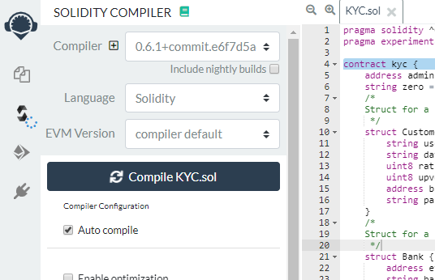
- Then compile the file
- In the deploy and run transaction chose as below
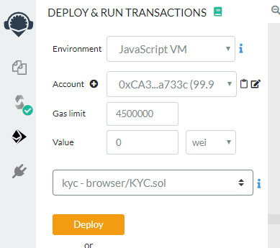
- Set the gas limit as above and click on Deploy
- After sucessful deployment expand the Deployed Contracts as below 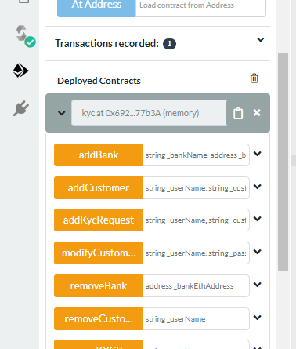
- Test Each Functionality By entering value to field
- 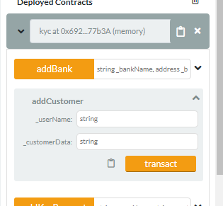

The flow of the Smart Contract is as below
- Admin/Smart contract account will add banks(2/3).
  - Method Name: addBank
  - Parameter : sbi, 0x14723A09ACff6D2A60DcdF7aA4AFf308FDDC160C , 1234
  - Parameter : hdfc,0x4B0897b0513fdC7C541B6d9D7E929C4e5364D2dB ,1235
- Each bank will do upvote for other banks
  - Method Name : upvoteBank
  - Parameter : 0x14723A09ACff6D2A60DcdF7aA4AFf308FDDC160C
- Bank will create KYC request for Customer
  - Method Name : addKycRequest
  - Parameter : customer1 , data1
  - Parameter : customer2 , data2

- Bank will verify the KYC data and then it may add to customer list or remove the KYC.
  - Method Name : addCustomer
  - Parameter : customer1 , data1

- Bank will Provide upvote for Customer.
  - Method Name : upvoteCustomer
  - Parameter : customer1

- Based on upvote, the rating of customer will change, If rating>.5 then it will be added to final customer list:

- Bank can set password for customer
  - Method Name : setPassword
  - Parameter : customer1 , pass1

- Bank can modify the customer data
  - Method Name : modifyCustomerData
  - Parameter : customer1 , pass1 ,newdata1

- Admin can remove any bank
  - Method Name : removeBank
  - Parameter : 0x4B0897b0513fdC7C541B6d9D7E929C4e5364D2dB

- Bank can view Bank details
  - Method Name : getBankDetails
  - Parameter : 0x14723A09ACff6D2A60DcdF7aA4AFf308FDDC160C

- Bank can view bank ratings
  - Method Name : getBankRating
  - Parameter : 0x14723A09ACff6D2A60DcdF7aA4AFf308FDDC160C
- Bank can view the list of KYC documents uploaded by bank but not verified yet.
  - Method Name : getBankRequests
  - Parameter : 0x14723A09ACff6D2A60DcdF7aA4AFf308FDDC160C

- Bank can view Customer data
  - Method Name : viewCustomer
  - Parameter : customer1 , pass1

- Bank can view Customer rating
  - Method Name : viewCustomerRating
  - Parameter : customer1

- Bank can view who has done the last modification to customer details.
  - Method Name : retriveAcessHistory
  - Parameter : customer1

